Assignment

Day 17

Monday, 27 September 2023

SV G2 / Intake #3

By: Ibrahim Tarek

**Table of Contents**

1. Executive Summary 3

2. Nested Vector Interrupt Controller. **Fehler! Textmarke nicht definiert.**

2.1. Main Features **Fehler! Textmarke nicht definiert.**

3. Interrupt Latency **Fehler! Textmarke nicht definiert.**

3.1. Definition **Fehler! Textmarke nicht definiert.**

3.2. Interrupt Latency Importance **Fehler! Textmarke nicht definiert.**

3.3. NVIC role in interrupt latency control **Fehler! Textmarke nicht definiert.**

4. NVIC interrupt tail-chaining **Fehler! Textmarke nicht definiert.**

5. Context Switching in ARM Cortex-M4 **Fehler! Textmarke nicht definiert.**

5.1. Exceptions and Context Switching **Fehler! Textmarke nicht definiert.**

5.2. ARM Cortex-M Specifics **Fehler! Textmarke nicht definiert.**

6. References 6

# Executive Summary

**This report discusses each of the following topics:**

1. Build process in C.

# System Timer

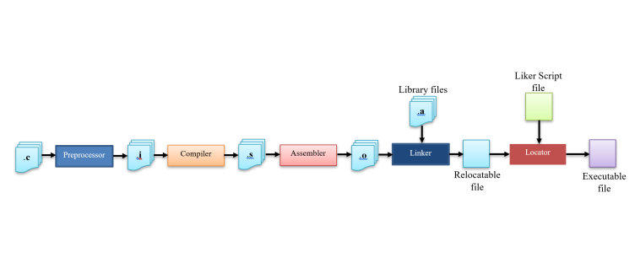C Build Process is considered one of the most important topics in the field of Embedded Software and it's the most famous question you will be asked in any Embedded Software interview.

# Preprocessor

Preprocessing is the first stage of C Build process in which all the preprocessor directives are evaluated.

* The input file for this stage is *.c file.
* The output file is *.i or preprocessed file.
* The preprocessor strips out comments from the input c file. Evaluate preprocessor directive by making substitution for lines started with #, and then produces a pure C code without any preprocessor directives.
* Note that if a bug/error happened in the preprocessor stage you normally won’t know its place as the output of the preprocessor goes directly into compiler, the error will be likely at the lines you used the preprocessor directive.

# Compiler

In this stage the C code gets converted into architecture specific assembly by the compiler; this conversion is not a one to one mapping of lines but instead a decomposition of C operations into numerous assembly operations. Each operation itself is a very basic task.

* The input file for this stage is *.i file.
* The output file is *.s or *.asm file.

# Assembler

In this stage the assembly code that is generated by the compiler gets converted into object code by the assembler.

* The input file for this stage is *.asm file.
* The output file is *.o or *.obj file.
* Note that compilers nowadays can generate an object code without the need of an independent assembler.
* The output of this stage is an object file that contains opcodes and data sections.

# Linker

In this stage the different object files that are generated by the assembler gets converted into one relocatable file by the linker.

* The input file for this stage is *.o file, and c standard libraries .
* The output file is relocatable file.
* While combining the object files together, the linker performs the following operations:
  1. Symbol resolution.
  2. Relocation.

# Locator

In this stage the process of assigning physical addresses to the relocatable file that is produced from the linker is performed using a locator.

* The input file for this stage relocatable file, and Linker script file.
* The output file is executable file.
* A locator is a tool that performs the conversion from relocatable program to executable binary image.
* The linker script file provides the locator with the required information about the actual memory layout and then the locator performs the conversion to produce a single executable binary file.
* Note that the locator can be found as a separate tool or with the linker.

# References

* 1. https://www.linkedin.com/pulse/c-build-process-details-abdelaziz-moustafa/